
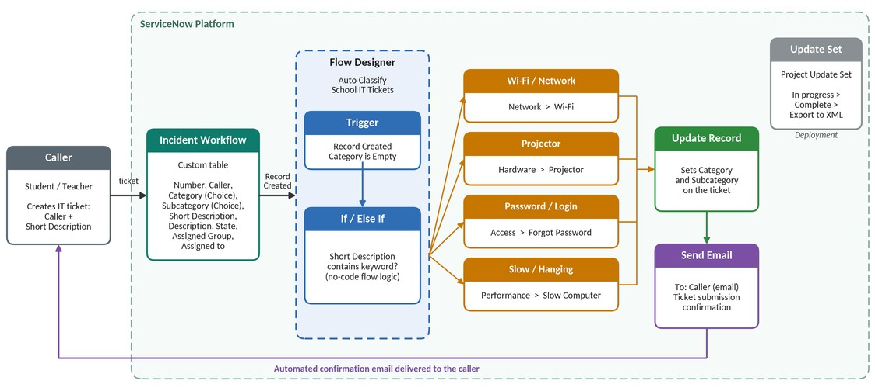
Project Design Phase Solution Architecture

Figure 1: Architecture and data flow of the Auto Ticket Classification solution
Reference:Project document – Auto Ticket Classification using Flow Designer (ServiceNow)
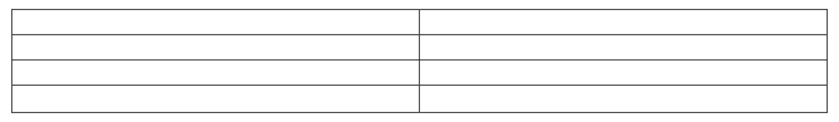
Date
Team ID Project Name
Maximum Marks
30 September 2026
4 Marks
Auto Ticket Classification using Flow Designer
SWTID-2026-7613

Solution Architecture:
Solution architecture is a complex process – with many sub-processes – that bridges the gap between business problems and technology solutions. Its goals are to:


- Find the best tech solution to solve existing business problems.
- Describe the structure, characteristics, behavior, and other aspects of the software to project stakeholders.
- Define features, development phases, and solution requirements.
- Provide specifications according to which the solution is defined, managed, and delivered.
Solution Architecture Diagram:

